Name: Naman Singh
CU24250110
43

<!DOCTYPE html>
<html lang="en">
<head>
<meta charset="UTF-8" />
<meta name="viewport" content="width=device-width, initial-scale=1.0" />
<title>EduTrack — Student Record Management System (Full-Stack CRUD)</title>
<meta name="description" content="A modern Full-Stack Student Record Management System demonstrating CRUD REST APIs with Express.js, MongoDB Mongoose, and Vanilla JavaScript fetch AJAX." />

<!-- Google Fonts: Inter & Outfit -->
<link rel="preconnect" href="https://fonts.googleapis.com" />
<link rel="preconnect" href="https://fonts.gstatic.com" crossorigin />
<link href="https://fonts.googleapis.com/css2?family=Inter:wght@300;400;500;600;700&family=Outfit:wght@500;600;700;800&display=swap" rel="stylesheet" />

<!-- Font Awesome Icons -->
<link rel="stylesheet" href="https://cdnjs.cloudflare.com/ajax/libs/font-awesome/6.5.1/css/all.min.css" />

<!-- Stylesheet -->
<link rel="stylesheet" href="style.css" />
</head>
<body>
<!-- Background Glows -->
<div class="glow glow-1"></div>
<div class="glow glow-2"></div>

<!-- Toast Notification Container -->
<div id="toast-container" class="toast-container" aria-live="polite"></div>

<!-- Main Container -->
<div class="app-container">

<!-- Header -->
<header class="navbar">
<div class="nav-brand">
<div class="logo-icon">
<i class="fa-solid fa-graduation-cap"></i>
</div>
<div class="brand-text">
<h1>EduTrack <span>Manager</span></h1>
<p class="subtitle">Full-Stack CRUD • Express.js &amp; MongoDB</p>
</div>
</div>
<div class="nav-actions">
<span class="status-pill online" id="server-status">
<span class="dot"></span> API &amp; DB Connected
</span>
<button id="btn-open-api-modal" class="btn btn-secondary">
<i class="fa-solid fa-code"></i> API Endpoints Guide
</button>
<button id="btn-seed-data" class="btn btn-outline" title="Populate sample students">
<i class="fa-solid fa-wand-magic-sparkles"></i> Add Sample Data
</button>
</div>
</header>

<!-- Stats Dashboard Cards -->
<section class="stats-grid">
<div class="stat-card">
<div class="stat-icon icon-blue">
<i class="fa-solid fa-users"></i>
</div>
<div class="stat-content">
<span class="stat-label">Total Students</span>

<h3 class="stat-value" id="stat-total">0</h3>
</div>
</div>

<div class="stat-card">
<div class="stat-icon icon-purple">
<i class="fa-solid fa-chart-line"></i>
</div>
<div class="stat-content">
<span class="stat-label">Average Marks</span>
<h3 class="stat-value" id="stat-avg">0.0</h3>
</div>
</div>

<div class="stat-card">
<div class="stat-icon icon-gold">
<i class="fa-solid fa-trophy"></i>
</div>
<div class="stat-content">
<span class="stat-label">Top Performer</span>
<h3 class="stat-value" id="stat-top">None</h3>
</div>
</div>

<div class="stat-card">
<div class="stat-icon icon-green">
<i class="fa-solid fa-circle-check"></i>
</div>
<div class="stat-content">
<span class="stat-label">Pass Rate</span>
<h3 class="stat-value" id="stat-pass">0%</h3>
</div>
</div>
</section>

<!-- Main Content Layout -->
<div class="main-layout">

<!-- Left Column: Add Student Form -->
<aside class="sidebar-card">
<div class="card-header">
<div class="card-title">
<i class="fa-solid fa-user-plus"></i>
<h2>Add Student Record</h2>
</div>
<p class="card-desc">Enter student credentials to save to database via <code>POST /students</code></p>
</div>

<form id="add-student-form" class="student-form" novalidate>
<!-- Name Field -->
<div class="form-group">
<label for="name">
Full Name <span class="required">*</span>
</label>
<div class="input-wrapper">
<i class="fa-regular fa-user field-icon"></i>
<input type="text" id="name" name="name" placeholder="e.g. Naman Singh" autocomplete="off" />
</div>
<span class="error-msg" id="error-name"></span>
</div>

<!-- Roll No Field -->
<div class="form-group">
<label for="rollNo">
Roll Number <span class="required">*</span>
</label>
<div class="input-wrapper">
<i class="fa-solid fa-id-badge field-icon"></i>
<input type="text" id="rollNo" name="rollNo" placeholder="e.g. 23CS101" autocomplete="off" />
</div>
<span class="error-msg" id="error-rollNo"></span>
</div>

<!-- Course Field -->
<div class="form-group">
<label for="course">
Course / Branch <span class="required">*</span>
</label>
<div class="input-wrapper">
<i class="fa-solid fa-book-bookmark field-icon"></i>
<select id="course" name="course">
<option value="" disabled selected>Select Course</option>
<option value="Computer Science & Engineering">Computer Science &amp; Engineering</option>
<option value="Artificial Intelligence & Data Science">Artificial Intelligence &amp; Data Science</option>
<option value="Information Technology">Information Technology</option>
<option value="Electronics & Communication">Electronics &amp; Communication</option>
<option value="Mechanical Engineering">Mechanical Engineering</option>
<option value="Civil Engineering">Civil Engineering</option>
</select>
</div>
<span class="error-msg" id="error-course"></span>
</div>

<!-- Marks Field -->
<div class="form-group">
<div class="label-with-preview">
<label for="marks">Marks (0 - 100) <span class="required">*</span></label>
<span id="grade-preview-badge" class="badge badge-preview">Grade: --</span>
</div>
<div class="input-wrapper">
<i class="fa-solid fa-percent field-icon"></i>
<input type="number" id="marks" name="marks" min="0" max="100" placeholder="e.g. 88" />
</div>
<span class="error-msg" id="error-marks"></span>
</div>

<!-- Form Actions -->
<div class="form-actions">
<button type="submit" id="btn-submit-student" class="btn btn-primary btn-block">
<i class="fa-solid fa-floppy-disk"></i> Save Student Record
</button>
<button type="button" id="btn-reset-form" class="btn btn-secondary btn-block">
<i class="fa-solid fa-rotate-left"></i> Reset Fields
</button>
</div>
</form>
</aside>

<!-- Right Column: Student Table & Directory -->
<main class="content-card">
<div class="card-header flex-header">
<div>
<div class="card-title">
<i class="fa-solid fa-table-list"></i>
<h2>Student Records Directory</h2>
</div>
<p class="card-desc">Live records fetched from MongoDB via <code>GET /students</code></p>
</div>
<button id="btn-refresh" class="btn btn-icon" title="Refresh Table">
<i class="fa-solid fa-arrows-rotate"></i>
</button>
</div>

<!-- Filter & Search Toolbar -->
<div class="toolbar">
<div class="search-box">
<i class="fa-solid fa-magnifying-glass"></i>
<input type="text" id="search-input" placeholder="Search by name, roll no, course..." />
<button id="btn-clear-search" class="clear-btn" style="display: none;">
<i class="fa-solid fa-xmark"></i>
</button>
</div>

<div class="filter-controls">
<select id="filter-course" class="select-control">
<option value="All">All Courses</option>
<option value="Computer Science & Engineering">Computer Science</option>
<option value="Artificial Intelligence & Data Science">AI &amp; Data Science</option>
<option value="Information Technology">Information Tech</option>
<option value="Electronics & Communication">Electronics</option>
<option value="Mechanical Engineering">Mechanical</option>
<option value="Civil Engineering">Civil</option>
</select>

<select id="sort-by" class="select-control">
<option value="createdAt-desc">Newest First</option>
<option value="createdAt-asc">Oldest First</option>
<option value="marks-desc">Marks: High to Low</option>
<option value="marks-asc">Marks: Low to High</option>
<option value="name-asc">Name: A to Z</option>
</select>
</div>
</div>

<!-- Table Container -->
<div class="table-container">
<table class="students-table" id="students-table">
<thead>
<tr>
<th style="width: 50px;">#</th>
<th>Student Info</th>
<th>Course</th>
<th>Marks</th>
<th>Grade</th>
<th>Status</th>
<th style="text-align: right; width: 140px;">Actions</th>
</tr>
</thead>
<tbody id="students-tbody">
<!-- Dynamically rendered rows -->
</tbody>
</table>

<!-- Empty State -->
<div id="empty-state" class="empty-state" style="display: none;">
<div class="empty-icon">
<i class="fa-solid fa-folder-open"></i>
</div>
<h3>No Student Records Found</h3>
<p>Add a new student using the form on the left or click "Add Sample Data" to get started.</p>
</div>

<!-- Loading Spinner -->
<div id="loading-spinner" class="loading-state">
<div class="spinner"></div>
<p>Fetching records from server...</p>
</div>
</div>
</main>

</div>
</div>

<!-- Edit Student Modal -->
<div id="edit-modal" class="modal-backdrop" style="display: none;">
<div class="modal-card">
<div class="modal-header">
<div class="modal-title">
<i class="fa-solid fa-pen-to-square"></i>
<h3>Edit Student Record</h3>
</div>
<button id="btn-close-modal" class="modal-close">&times;</button>
</div>

<form id="edit-student-form" class="student-form" novalidate>
<input type="hidden" id="edit-id" />

<div class="form-group">
<label for="edit-name">Full Name <span class="required">*</span></label>
<div class="input-wrapper">
<i class="fa-regular fa-user field-icon"></i>
<input type="text" id="edit-name" required />
</div>
<span class="error-msg" id="edit-error-name"></span>
</div>

<div class="form-group">
<label for="edit-rollNo">Roll Number <span class="required">*</span></label>
<div class="input-wrapper">
<i class="fa-solid fa-id-badge field-icon"></i>
<input type="text" id="edit-rollNo" required />
</div>
<span class="error-msg" id="edit-error-rollNo"></span>
</div>

<div class="form-group">
<label for="edit-course">Course / Branch <span class="required">*</span></label>
<div class="input-wrapper">
<i class="fa-solid fa-book-bookmark field-icon"></i>
<select id="edit-course" required>
<option value="Computer Science & Engineering">Computer Science &amp; Engineering</option>
<option value="Artificial Intelligence & Data Science">Artificial Intelligence &amp; Data Science</option>
<option value="Information Technology">Information Technology</option>
<option value="Electronics & Communication">Electronics &amp; Communication</option>
<option value="Mechanical Engineering">Mechanical Engineering</option>
<option value="Civil Engineering">Civil Engineering</option>
</select>
</div>
<span class="error-msg" id="edit-error-course"></span>
</div>

<div class="form-group">
<label for="edit-marks">Marks (0 - 100) <span class="required">*</span></label>
<div class="input-wrapper">
<i class="fa-solid fa-percent field-icon"></i>
<input type="number" id="edit-marks" min="0" max="100" required />
</div>
<span class="error-msg" id="edit-error-marks"></span>
</div>

<div class="modal-actions">
<button type="button" id="btn-cancel-modal" class="btn btn-secondary">Cancel</button>
<button type="submit" id="btn-save-edit" class="btn btn-primary">
<i class="fa-solid fa-check"></i> Update Record
</button>
</div>
</form>
</div>
</div>

<!-- API Endpoints Guide Modal -->
<div id="api-modal" class="modal-backdrop" style="display: none;">
<div class="modal-card modal-large">
<div class="modal-header">
<div class="modal-title">
<i class="fa-solid fa-network-wired"></i>
<h3>REST API Specification &amp; Postman Guide</h3>
</div>
<button id="btn-close-api-modal" class="modal-close">&times;</button>
</div>

<div class="api-doc-body">
<p class="api-doc-intro">
This system implements all 5 CRUD REST endpoints specified in Lab Sheet 9. You can test them using Postman or cURL.
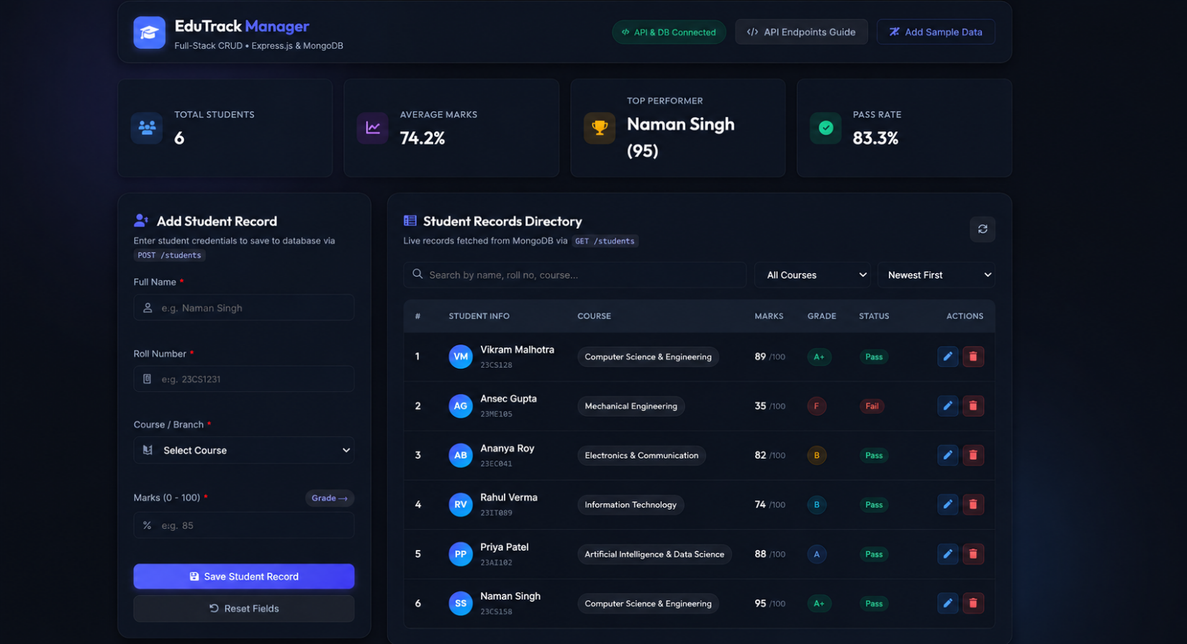
z

